**Comparing Portfolio Performances**

Jose Zuniga (Coding, Presentation)

Jing Shuai (Coding, Presentation)

Paul-Richard Cherival (Report)

Wei Dai (No Contribution)

Zicklin School of Business

Abstract

The objective of a good fund manager is too maximize investor’s return while minimizing exposure to risk subject to a client’s risk tolerance. Much research has been done on portfolio investment strategies and as result, we know of several approaches to optimizing a portfolio of assets. Depending on the situation however, each model has its pros and cons. This paper evaluates several portfolio investment strategies.

Keywords: Sharpe Ration, PCA, Maximum Drawdown, Bootstrapping

Comparing Portfolio Performances

# Motivation

With information and computational power easily accessible, there is great incentive for Portfolio managers to leverage these resources to maximize returns. In our paper we construct portfolios using different approaches. Then, using metrics such as Sharpe Ratios, Maximum Drawdowns and Turn-Over Rates we will determine the best approach to maximize return.

**INVESTMENT STRATEGIES**

**Minimum Variance Portfolio.**

The Minimum Variance Portfolio model consists of allocating our investment budget towards our stocks in a manner which minimizes the overall risk of the portfolio. This is done by setting the derivative of the matrix equation for variance to zero and then solving for the weights.

**Tangency Portfolio with Risk-free Asset**

The Tangency Portfolio with a risk free asset is an unleveraged variation of the Minimum Variance Portfolio which introduces a risk free asset and then optimizes the mean-variance combination to achieve the best risk-reward tradeoff (highest Sharper Ratio) possible.

**Capital Asset Pricing Model**

The Capital Asset Pricing Model regresses a given portfolio– in our case the Tangency Portfolio with Risk-free Asset—against a benchmark to understand its sensitivity to variations in the benchmark in terms of standard regression metrics.

**Nonparametric Bootstrap Portfolio**

Nonparametric Bootstrapping consists of making no assumption on the distribution of the data, sampling the empirical data with replacement multiple times, and calculating the Tangency Portfolio each time in order to estimate the return and variance of the population. Since the empirical sample approximates the population from which it was drawn, resamples from this sample approximate what we would get if we took many samples from the population. The issue encountered with this method is that there are large outliers in the data which appear multiple times in some of the resamples. This overrepresentation skews the results significantly and robust mean-trimming is needed. Yet even with a 5% trim, results still appear unrealistic.

**Target Return Portfolio**

The Target Return portfolio is a mean-variance optimization of the Tangency Portfolio where variance is minimized subject to a declared mean (target return) using Lagrange multipliers.

**Target Return Portfolio with Risk-free Asset**

The Target Return Portfolio with Risk-free Asset is equivalent to the Target Return Portfolio described above but also allows for leveraging in the model using a risk free asset.

**Principal Component Analysis**

Principal Component Analysis consists in identifying the elements of a dataset which best explain the variance. In the case of portfolio construction, the aim is to identify the linear combination of stocks which contribute to the highest risk. Since our assets within the 25 largest holdings in the S&P 500, they are highly correlated and result in two principal components explaining 91% of the variance in the portfolio.

APPROACH

In order to evaluate the different investment strategies, we picked 20 stocks from the Standard & Poor's 500 (S&P 500) American stock market index and analyzed their returns over a seven year period (January 1, 2007 to December, 1 2014). The 20 stocks chosen were the top holdings which have been part of the index for the entire period of evaluation. We use the same assets in each portfolio strategy evaluated. Our portfolio consist of the following set of fairly diversified large-cap stocks: Apple (AAPL), Exxon Mobil (XOM), Microsoft (MSFT), Johnson & Johnson (JNJ), General Electric (GE), Wells Fargo Company (WFC), Proctor & Gamble (PG), JP Morgan Chase (JPM), Chevron Corp. (CVX), Verizon (VZ), Pfizer (PFE), Intel (INTC), Bank of America (BAC), AT&T (T), Merck & Co (MRK), Coca Cola (KO), Citigroup (C), International Business Machines (IBM), Google (GOOGL), Gilead Sciences (GILD).

**Portfolio Performances**

During the period in review, the S&P500 had a 9.2% return with a standard deviation of 22.2% and 0.504 Sharpe ratio (Table 1). Yet in spite of this positive return, each investment strategy outperformed the benchmark with bootstrapping yielding the highest return and Sharpe ratio of 71% and 1.11 respectively, and Principal Component Analysis yielding the lowest risk with a 13.1% standard deviation.

**Risk Management**

The results for Value-at-Risk and Expected Shortfall using a $10,000,000 initial investment became essentially a ranking of standard deviations. The higher the standard deviation the more value was at risk and the greater the expected shortfall. Hence, Principal Component Analysis gave the lowest VaR and ES, while bootstrapping gave the highest.

**Take Away and Further Study**

With the stocks being constant across each portfolio in our analysis it became evident that each strategy had its benefits and drawbacks. With this in mind we were able to tailor portfolios to meet clients’ long and short term goals. Moreover, understanding how each strategy performs under various market conditions will help optimize when to

Tables Performance Summary

Table 1

***Period***

* *start = "2007-01-01"*
* *end = "2014-12-01"*

**S&P500 Index (Benchmark)**

* *Mean = 0.09166378*
* *Standard Deviation = 0.2224576*
* *Sharpe Ratio = 0.3221458*
* *Maximum Draw Down = 1.852949*

***Minimum Variance Portfolio***

* *Mean = 0.09305468*
* *Standard Deviation = 0.1450562*
* *Sharpe Ratio = 0.5036302*
* *Maximum Draw Down = 2.968063*

***Tangency Portfolio with Risk Free Asset***

* *Mean = 0.34323781*
* *Standard Deviation = 0.3051219*
* *Sharpe Ratio = 1.0593728*
* *Maximum Draw Down = 1.794105*

***Capital Asset Pricing Model***

*Coefficients:*

*Estimate Std. Error t value Pr(>|t|)*

*(Intercept) 0.29336 0.09965 2.944 0.00328 \*\**

*t(R_SPY) 0.54413 0.02822 19.284 < 2e-16 \*\*\**

*Signif. codes: 0 ‘***’ 0.001 ‘**’ 0.01 ‘*’ 0.05 ‘.’ 0.1 ‘ ’ 1*

*Residual standard error: 4.447 on 1991 degrees of freedom*

*Multiple R-squared: 0.1574, Adjusted R-squared: 0.157*

*F-statistic: 371.9 on 1 and 1991 DF, p-value: < 2.2e-16*

***Nonparametric Bootstrap Tangent Portfolio***

* *Resamples = 10^5*
* *Time @ 1.8 GHz = 10.46968 mins*
* *Robust Mean (0.05 Trim) = 0.71230152*
  + *Outlier Returns in Dataset*
  + *[1] 0.5782493 8.7699115*
  + *[1] -0.5066259 -0.5012057 -0.5030242 -0.4965201 -0.8548569*
* *Standard Deviation = 0.5486998*
* *Sharpe Ratio = 1.2617126*
* *Maximum Draw Down = 3.056742*

***Target Return Portfolio***

* *Mean = 0.5*
* *Standard Deviation = 0.4601001*
* *Sharpe Ratio = 1.0432513*
* *Maximum Draw Down = 1.765257*

***Target Return Portfolio with Risk-free Asset***

* *Mean = 0.5*
* *Standard Deviation = 0.4530983*
* *Sharpe Ratio = 1.0593728*
* *Maximum Draw Down = 1.765257*

***Principal Component Analysis***

* *Mean = 0.16556244*
* *Standard Deviation = 0.1307560*
* *Sharpe Ratio = 1.1132370*
* *Maximum Draw Down = 1.615135*

Tangency Plot

Benchmark

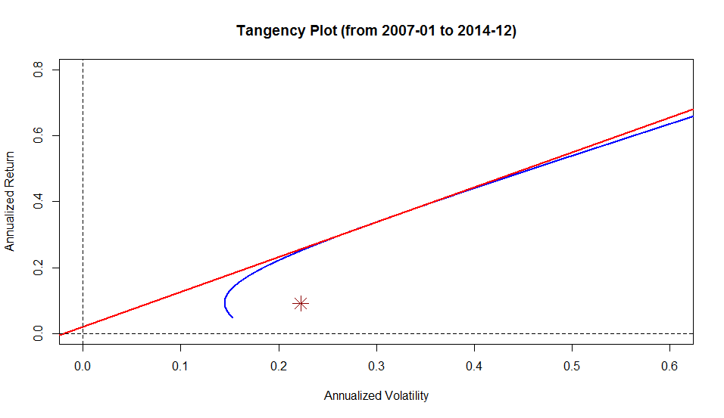

Minimum Variance Portfolio

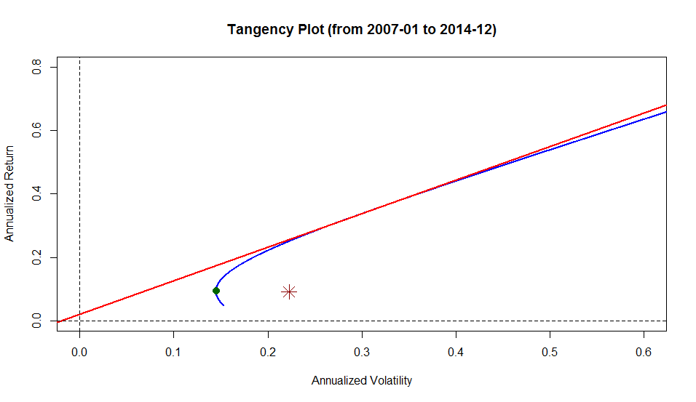

Tangency Portfolio

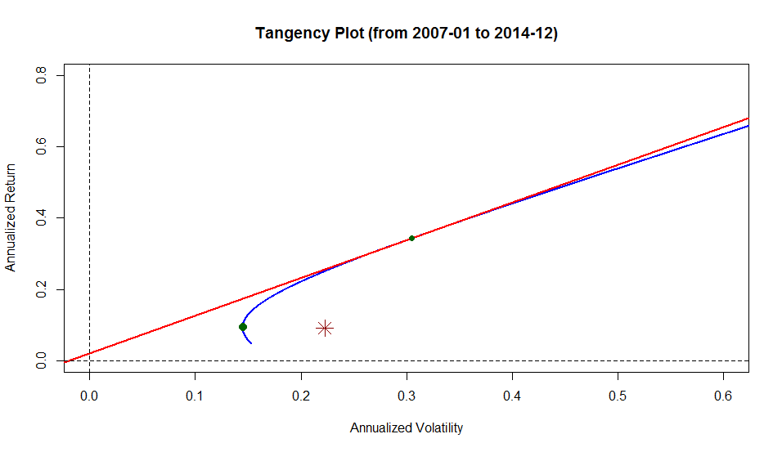

Nonparametric Bootstrap Tangency Portfolio  
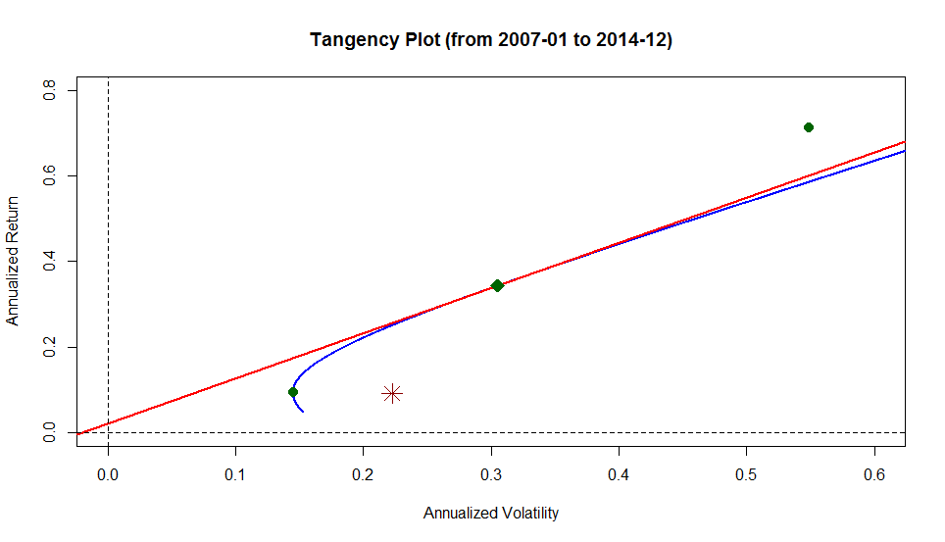

Target Return Portfolio  
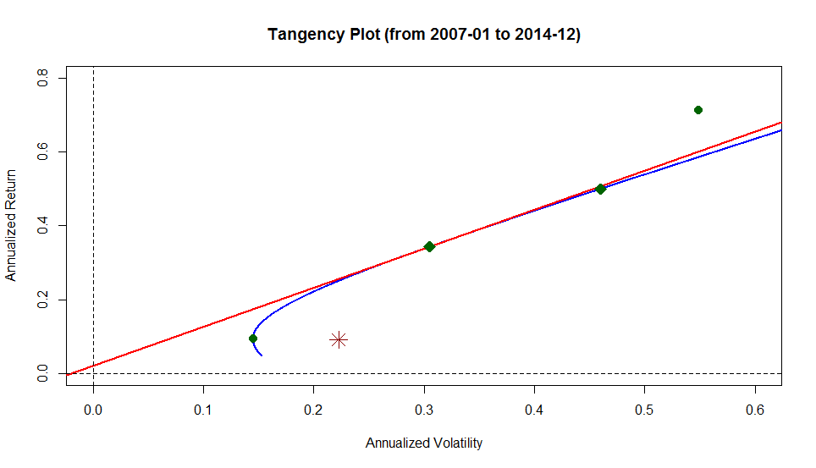

Target Return Portfolio with Risk Free Asset  
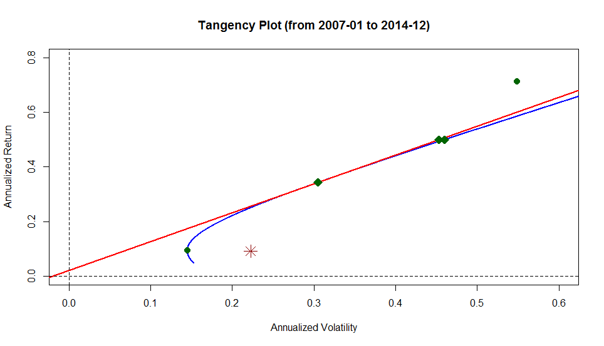

Principal Component Analysis

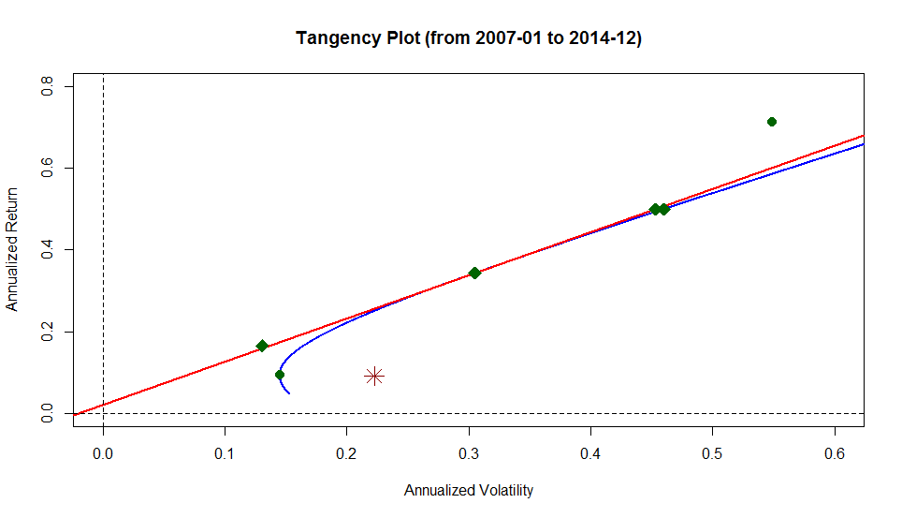

In Memory

of

Timothy Richman

11/22/1982 – 11/28/2014